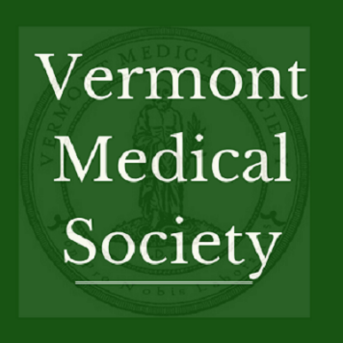
Vermont Medical Society 2018 Priorities

Ensure Vermont is the best state to practice medicine
- Vermont Reduces the Administrative Burden Placed on Health Care Practices
  - Streamline and reduce prior authorizations and quality measurements; EHRs interconnected and designed for patient care
  - Continue and support the work of the GMCB Primary Care Advisory Group;
- Health Reform in Vermont Reflects Clinical Practice
  - GMCB membership includes a health care professional;
  - Physician practices understand and can assess potential benefits of the All-Payer Model
- Timely and Fair Medicaid Policies
  - 2018 bill to require DVHA to enroll Medicaid providers within 60-days;
  - 2018 bill to require DVHA to review their recoupment practices for practices acting in good faith
- Workforce recruiting and retention
  - Interstate Medical Licensing Compact – 2018 bill would allow Vermont qualified physicians an expedited path for licensure to practice in multiple states;
  - Maintain a sensible role for the Board of Medical Practice in access to internal employer disciplinary actions
Addressing Vermont’s Opioid Epidemic
- Ensure VDH rules on opioid prescribing reflect best patient care
- Ensure VPMS remains a clinical tool
- Retain prescribing ability for those health care professionals with adequate medical training
- Limit medical marijuana use to only those conditions with proven scientific evidence showing safety and efficacy
- Oppose legalization of non-medical marijuana

What is the Vermont Medical Society?
The Vermont Medical Society (VMS) is the largest physician membership organization in the state, representing over 2000 physicians, physician assistants and medical students across all specialties and geographic locations. VMS is a 501(c)(6) nonprofit organization founded in 1784, dedicated to improving the environment in which Vermont physicians practice medicine, and to protecting the health of Vermont citizens.

VMS Organization
VMS is made up of 2416 members, which represents 2/3 of practicing physicians & PAs in Vermont, along with 460 medical students. Our members include primary care, specialists and all employer-types (hospital-employed, FQHC, independent practice)
VMS also operates the:
- Vermont Specialty Societies: Pediatrics, Family Practice, Internal Medicine, Ophthalmology, Orthopedics, Psychiatry, Anesthesiology, Surgeons, Orthopedics
- Vermont Practitioner Health Program under contract with Board of Medical Practice to serve licensees with an impaired ability to practice
- VMS Education and Research Foundation: independent 501(c)(3) that supports education, improvement and evaluation in the field of health
VMS Physician Leadership
President: Trey Dobson, MD (emergency medicine, Chief Medical Officer, Southwestern Vermont Medical Center) president@vtmd.org
President-elect: Stephen Leffler, MD (emergency medicine, Chief Population Health and Quality Officer, UVMMC)
Vice President: Catherine Schneider, MD (General Surgery, Mt. Ascutney)
Immediate Past-President: Wendy Davis, MD (pediatrician, UVMMC)

Thank you! from the VMS Policy Staff
Jessa Barnard, Executive Director – jbarnard@vtmd.org
Stephanie Winters, Deputy Executive Director – swinters@vtmd.org
Jill Sudhoff-Guerin, Policy and Communications Manager – jsudhoffguerin@vtmd.org

