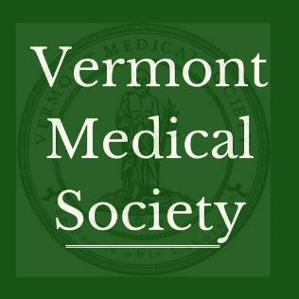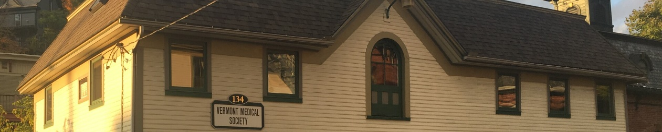

Welcome to the Vermont Medical Society

**2023 Legislative Agenda**

**da**

**Practice Sustainability**

**COVID-19 Response**

* Significant investment in primary care, including increased:
  + Medicaid payments for primary care;
  + Percent of commercial and Medicare spending on primary care;
  + Blueprint for Health/practice transformation support
* Pay parity for audio-only telehealth services
* Updated Workers’ Compensation Fee Schedule
* Clinician voice in future All-Payer Model & Hospital Global Budget Design

**Reducing Administrative Burden**

**COVID-19 Response**

* Expanding “gold card” programs
* Increased prior authorization auto approvals/tools embedded into EHRs

**Ensuring a Strong Workforce**

**COVID-19 Response**

* Ongoing funding for primary care scholarships
* Increased loan repayment and residency training programs
* Meeting statewide economic development needs like housing & childcare

**Supporting Public Health**

**COVID-19 Response**

* Urging adequate prevention funding, limited advertising, potency limits in cannabis sales
* Supporting legal protections for reproductive rights, including laws to protect health care professionals and patients who provide/seek services across state lines
* Allowing minors to consent to STI prevention services
* Increasing pediatric and adult mental health care capacity
* Ensuring 12 weeks of universal paid leave for all parents
* Guaranteeing access to health care during arrest or while in custody

What is the Vermont Medical Society (VMS)?



**What is the Vermont Medical Society (VMS)?**

VMS is the largest physician membership organization in the state, representing over 2600 physicians, physician assistants and medical students across all specialties and geographic locations. VMS is a 501(c)(6) nonprofit founded in 1784, dedicated to protecting the health of all Vermonters and improving the environment in which Vermont physicians and physician assistants practice medicine. See our brochure at: <https://vtmd.org/join-vms>.

VMS Organization

**VMS is made up of 2600 members,** which represents 2/3 of practicing physicians & PAs in Vermont, along with 460 medical students. Our members include primary care, specialists and all employer-types (hospital-employed, FQHC, independent practice)

***VMS also operates the:***

* *Vermont Specialty Societies*: Pediatrics, Family Practice, Internal Medicine, Ophthalmology, Orthopedics, Psychiatry, Anesthesiology, Surgeons, Orthopedics, Osteopathic Physicians, Addiction Medicine.
* *Vermont Practitioner Health Program* under contract with Board of Medical Practice to serve licensees with an impaired ability to practice medicine.
* *VMS Education and Research Foundation*: independent 501(c)(3) that supports educational and charitable activities –offering physician leadership training course, student scholarship.

VMS Physician Leadership

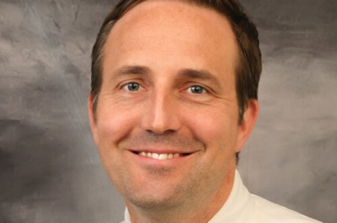

**President**

**Simha Ravven, MD**

Psychiatry,

Chief Medical Officer, Howard Center

**President-elect**

**Ryan Sexton, MD** Emergency Medicine, Northeastern VT Regional Hospital

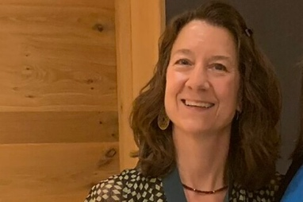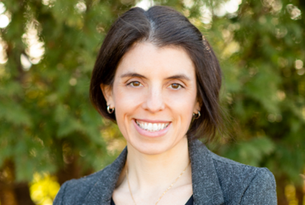

**Immediate Past-President** **Catherine Schneider, MD** General Surgery, Mt. Ascutney Hospital

**Vice-President**

**Becca Bell, MD**, Pediatric Intensivist, University of Vermont Medical Center

VMS Policy Staff

**Jessa Barnard**, Executive Director, [jbarnard@vtmd.org](mailto:jbarnard@vtmd.org)

**Stephanie Winters**, Deputy Director, [swinters@vtmd.org](mailto:swinters@vtmd.org)

**Jill Sudhoff-Guerin**, Policy & Communications Consultant, [jsudhoffguerin@vtmd.org](mailto:jsudhoffguerin@vtmd.org)